## **Kpi’s requirement**

We need to analyze key indicators for our sales data to gain insights into our business performance. Specifically, we want to calculate the following metrics :

**SQL QUERIES**

1. **Total revenue**

select * from pizza_sales;

select SUM(total_price) as total_revenue from pizza_sales

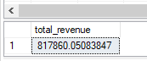

1. **Average order value**

use [Pizza DB]

go

select * from dbo.pizza_sales;

select sum(total_price) / count(distinct order_id) as average_order from dbo.pizza_sales



1. Total Pizza Sold

select sum(quantity) as total_order_sold from dbo.pizza_sales



1. Total Order Placed

use [Pizza DB]

go

select * from dbo.pizza_sales

select count(distinct order_id) as total_order_placed from dbo.pizza_sales



1. Average pizza per order

Select sum(quantity) / count(distinct order_id) as average_pz_per_order from dbo.pizza_sales



* Ta có thể lấy ra giá trị k chính xác, ví dụ giá trị là các số thập phân như 2.5, 2.67… nên convert sang decimal :

Select cast(sum(quantity) as decimal(10,2)) /

Cast(count(distinct order_id) as decimal(10,2)) as average_pz_per_order from dbo.pizza_sales

## 

## **Charts requirement**

We would like to visualize various aspects of our pizza sales data to gain insights and understand key trends. We have identified the following requirements for creating charts :

1. **Daily trend for total orders**

* Tính tổng số đơn hàng theo từng ngày trong tuần :

use [Pizza DB]

go

select datename(DW, order_date) as order_day, count(distinct order_id) as total_order

from dbo.pizza_sales

group by datename(DW, order_date)

order by datename(DW, order_date)

* Giải thích code :

DATENAME(DW, order_date): Lấy **tên ngày trong tuần** từ cột order_date.

DW: Viết tắt của **Day of Week**, trả về tên ngày trong tuần (ví dụ: "Monday", "Tuesday").

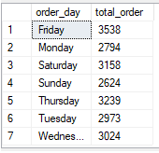

1. **Hourly trend**

select datepart(HOUR, order_time) as order_time, count(distinct order_id) as total_order

from dbo.pizza_sales

group by datepart(hour, order_time)

order by datepart(hour, order_time)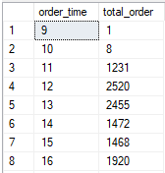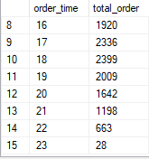

1. **Percentage of sales by pizza category**

* Cách tính : ta lấy tổng tiền theo từng phân loại chia cho toàn bộ doanh thu

select pizza_category,

sum(total_price) as total_sales,

sum(total_price) * 100/ (select sum(total_price) FROM pizza_sales )as Percent_sales

from dbo.pizza_sales

group by pizza_category

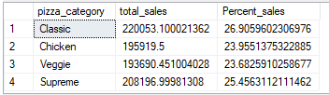

* Lọc doanh thu theo tháng

select pizza_category,

sum(total_price) as total_sales,

sum(total_price) * 100/ (select sum(total_price) FROM pizza_sales )as Percent_sales

from dbo.pizza_sales

where MONTH(order_date) = 1

group by pizza_category

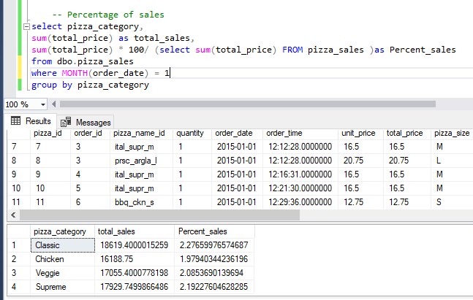

1. **Percentage of sales by pizza size**

select pizza_size,

sum(total_price) as total_sales,

sum(total_price) * 100/ (select sum(total_price) FROM pizza_sales )as Percent_sales

from dbo.pizza_sales

group by pizza_size

order by Percent_sales

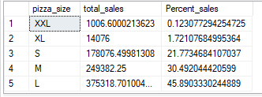

1. **Total pizza sold by pizza category**

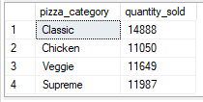

select pizza_category,

sum(quantity) as quantity_sold

from dbo.pizza_sales

group by pizza_category

1. Top 5 best seller by total pizza sold

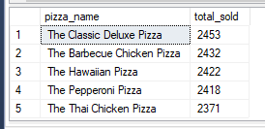

select top 5 pizza_name,

sum(quantity) as total_sold

from dbo.pizza_sales

group by pizza_name

Order by total_sold DESC